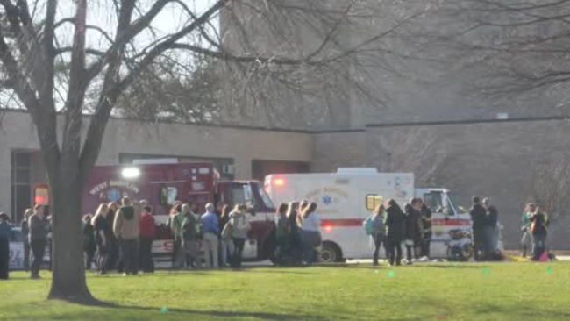


Tabletop Exercise

After Action Report

Improvement Plan
2020 Regional Exercise
Scenario: Pediatric Surge

JANUARY 29, 2020

Hosted by: Georgia Mountains Healthcare Coalition (Region B)

Published May 20, 2020

Note: This After-Action Report (with included Improvement Plan Appendix) aligns selected exercise objectives with preparedness doctrine to include the National Preparedness Goal and related frameworks and guidance.

Findings in this report are based upon observations of exercise facilitators and evaluators in addition to feedback provided by exercise participants.

Table of Contents
Handling Instructions 4
Exercise Overview 5
Exercise Planning and Participation 6
Exercise Planning Team (EPT) 6
Participating Organizations 6
Number of Attendees 6
Tabletop Exercise Planning and Preparation 6
Executive Summary 7
Summary of Core Capability Performance 8
Analysis of Exercise Objectives 10
Appendix A: Improvement Plan Worksheet 15
Appendix C: Georgia Mountains Healthcare Coalition (Region B) 19
Executive Committee Contacts 19
Appendix D: Role of Children’s Healthcare of Atlanta (CHOA) 20
Appendix E: New WebEOC Guide 21
Appendix F: Region B Coalition Members WebEOC Login Information (password = epr12345) 23
Appendix G: Region B Healthcare Facility Bed Counts 24
Appendix H: GHA911 WebEOC Event Log - TTX 25
Appendix I: Georgia Mountain Healthcare Coalition EverBridge Messages 31
Appendix J: Acronyms 32
Appendix K: Regional Coordinating Hospital Area Map 33
Appendix L: Public Health Districts Map 34
Appendix M: GEMA Regions Map 35
Appendix N: 36
Appendix O: Georgia ARES Districts Map 37
Appendix Q: GEMA Regions Map 39

Handling Instructions
The title of this document is Georgia Mountains Healthcare Coalition (GMHC) Pediatric Surge Tabletop Exercise (TTX) After Action Report (AAR).
The information gathered in this AAR is For Official Use Only and should be handled as sensitive information not to be disclosed. This document should be safeguarded, handled, transmitted, and stored in accordance with appropriate security directives. Reproduction of this document, in whole or in part, without prior approval from the Georgia Mountains Healthcare Coalition EPT, or the Georgia Mountains Healthcare Coalition Regional Coordinating Hospital, Northeast Georgia Health System, is prohibited.

For more information, please consult the following points of contact:
Georgia Mountains Healthcare Coalition (Region B) RCH Northeast Georgia Health System
Name | Phone | Email
Matthew Crumpton, NRP, MEP, CEM-GA, EMHP  Emergency Preparedness Manager | Mobile: 678.630.5955  Office: 770.219.1823 | Matthew.Crumpton@nghs.com
Frances Franks, BSN, RN, EMHP  Coalition Clinical Advisor | Mobile: 334.444.2651 | Frances.Franks@nghs.com

Exercise Overview
Exercise Name | Georgia Mountains Healthcare Coalition –Regional Pediatric Surge Tabletop Exercise
Exercise Date | January 29, 2020
Purpose | To review both local and regional coordination in an effort to address preparedness gaps and identify areas for improvement in response to a regional pediatric scenario.
Scope | This discussion-based exercise focuses on Georgia Mountains Healthcare Coalition healthcare facilities’ and community partners’ ability to respond to a regional pediatric surge event. This will include reviewing local and regional response plans, as well as engaging in discussion to address potential gaps that may exist.
Mission Areas | Prevention, Protection, Mitigation, and Response
Core Capabilities | Cap 1: Foundation for Health Care and Medical Readiness  Cap 2: Health Care and Medical Response Coordination  Cap 3: Continuity of Health Care Service Delivery  Cap 4: Medical Surge
Objectives | - Review regional and internal plans, policies, and procedures of The GMHC Region’s healthcare facilities and community partners needed to respond to a regional pediatric surge incident;  - Review communications plans involving incident notification and ongoing situational awareness among area healthcare facilities, local governments, and regional partners;  - Review internal surge plans, and;  - Review procedures for establishing command and control operations
Threat or Hazard | Pediatric Surge at Medical Facility
Scenario | On January 29, 2020 at 0945, local EMS notifies Med Transport of reports of a school explosion during a rural school assembly. Initial reports indicate as many as 50 children and adults in the area at the time of the explosion. Estimated number of casualties is unknown, but initial 911 calls report that the situation is dire. Patients begin to present to the small local ED by 1000. Resources are quickly overwhelmed in the small community.
Sponsors | Georgia Mountains Healthcare Coalition, Northeast Georgia Health System Regional Coordinating Hospital; Georgia Department of Public Health
Participating Organizations | 39 participating Healthcare Organizations and Community Partners (see page 6 for complete listing)

Exercise Planning and Participation

Exercise Planning Team (EPT)
Representatives of the following organizations participated in the Georgia Mountains Healthcare Coalition Tabletop Exercise planning process by attending scheduled regional exercise planning meetings:
- District 2 Public Health
- Northeast Georgia Health System

Participating Organizations
The following organizations were represented at the Georgia Mountains Healthcare Coalition Tabletop Exercise:
Amateur Radio Emergency Service | Gold City Health and Rehab | NGHS Medical Transport
Amedisys Home Health | Gold City Personal Care Center | New Horizons Lanier Park
ARES Hall County | Habersham Medical Center | New Horizons Limestone
Banks County Coroner | Hall County EMA | Ethica Health
Buford DaVita | Region 2 Office of EMS and Trauma | Stephens County EMA
Calhoun Health Care Center | Habersham Home | PruittHealth Home Health
Chatuge Regional Hospital | Lanier Village Estates | PruittHealth Hospice
Chelsey Park Health and Rehab | Mountain Lakes Medical Center | Stephens County Hospital
District 2 PH | NGMC Barrow | PruittHealth Toccoa
Gateway Health and Rehab | NGMC Braselton | The Oaks Limestone
Georgia Hospital Association | NGMC Gainesville | Union General Hospital
Georgia Mountains Healthcare | NGHS Hospice | University of North Georgia
Gold City Health and Rehab | NGMC Lumpkin | Willowbrook Court

Number of Attendees
Number of Attendees
Logistics/Support………………………………….3
Participants………………………….…….……….69
TOTAL: 73 attendees

Tabletop Exercise Planning and Preparation
In preparation for the exercise, the following meetings were held:
November 20, 2019 Tabletop Exercise
Concepts & Objectives (TTX C&O) & Tabletop Exercise Initial Planning Meeting (TTX IPM)
December 5, 2019 Tabletop Exercise Midterm Planning Meeting (TTX MPM)
December 27, 2019 Tabletop Exercise Final Planning Meeting (TTX FPM)

Executive Summary

The Georgia Mountains Healthcare Coalition Pediatric Surge Tabletop Exercise was held on January 29, 2020 at Lanier Technical College in Gainesville, Georgia. The 69 Region B participants included representatives from many coalition healthcare facilities, local community response partners, and state and regional support agencies. The purpose of this exercise was to review individual facility/agency Surge response plans, state-level Pediatric Surge coordination and transport plans, in an effort to address preparedness gaps and identify areas for improvement in response to patients presenting. The Georgia Mountains Healthcare Coalition tabletop exercise focused on the coalition’s ability to respond to a pediatric surge at a frontline facility scenario affecting healthcare facilities and their partners across the region. Tabletop participants were seated with county partners in order to facilitate discussion of both local and regional plans. The exercise sought to identify gaps in capabilities that currently exist in both local response plans and the Georgia Mountains Healthcare Coalition’s Communication Coordination Plan.
The following areas were recognized as major strengths of the Georgia Mountains Healthcare Coalition during the exercise:
- Region B frontline facilities are very active in Preparedness Planning and training, as evidenced by robust participation in Coalition meetings from diverse provider types as well as representation and presence from all hospitals within the region at the TTX. The Coalition’s growing membership shows the strength in those relationships and community partnerships with local EM, thus proving sustainability.
- Participants from most organizations in Region B report adequate access to training opportunities addressing surge capacity and pediatric specific MCI planning, including tabletop exercises as well as full scale.

- Most frontline facilities within Region B are aware of Coalition Information Sharing Procedures and Platforms and report adequate access and training on systems such as Everbridge Mass Notification and WebEOC. Region B partners recognize the importance of The HCC Communication Plan and participate in regular communication drills in addition to utilizing these information sharing systems within their individual organizations.

- Most participating facilities were aware of available community partners and local resources, and report knowledge and utilization of the Regional Communication Coordination Plan and the resources available through the Georgia Mountains Healthcare Coalition.
- Some Region B facilities have internal surge capacity plans in place that specifically address pediatric capabilities, communication, staffing and resources, and special considerations while other facilities report including procedures of referring to CHOA for specific information.

The primary identified regional opportunities for improvement were as follows:
- Most participating organizations identified more funding and access to Pediatric Specific Training for their staff as an opportunity for improvement, especially those who do not encounter pediatric patients frequently.
- Most organizations identified gaps within their internal communication plans regarding consistent messaging to staff and the public during an incident, as well as strategies to support family reunification and security issues.
- Though many frontline facilities have adequate incident response plans in place, most are unclear on exactly what their staffing and supply needs would be during a pediatric surge incident and how those needs would be sustained during an ongoing incident.
- Some organizations report a lack of grief support and critical incident stress management within their emergency operation plans.
- Most participating facilities identified gaps in communication of and education on Pediatric response plans and training for staff, and acknowledge the need for better information and representation from CHOA
- Some participating facilities report a need for better patient identification, tracking, and reunification during an incident and also question morgue capacity within their facility as well as accessing regional resources.

Regional Analysis of Core Capabilities
Aligning exercise objectives and core capabilities provides a consistent taxonomy for evaluation that transcends individual exercises to support preparedness reporting and trend analysis. Table 1 includes the exercise objectives, aligned core capabilities, and performance ratings for each core capability as observed during the exercise and determined by the evaluation team.

Summary of Core Capability Performance
Objective | Core Capability | Discussed with No Gaps Identified (N) | Discussed with Some Gaps Identified (S) | Discussed with Major Gaps Identified (M) | Unable to be Discussed (U)
- Participants will review regional and internal plans, policies, and procedures of The GMHC Region’s healthcare facilities and community partners needed to respond to a regional pediatric surge incident | Health Care and Medical Readiness |  | S
- The Georgia Mountains Healthcare Coalition will review communications plans involving incident notification and ongoing situational awareness among area healthcare facilities, local governments, and regional partners | Health Care and Medical Response Coordination |  | S
- Georgia Mountains Healthcare Coalition healthcare facilities and response partners will review procedures for establishing command and control operations | Continuity of Health Care Service Delivery |  | S
- The Georgia Mountains Healthcare Coalition members will review internal surge plans. | Medical Surge |  | S
Ratings Definitions:
- Discussed with No Gaps Identified (N): The targets and critical tasks associated with the capability were discussed in a manner that fully addressed the objective(s) without identifying any operational gaps in current policies, plans, and protocols. Existing policies, plans, and protocols are effective and are not perceived to need additional updates at this time. Staff members are fully trained and understand the existing protocols.
- Discussed with Some Gaps Identified (S): The targets and critical tasks associated with the capability were discussed in a manner that addressed the objective(s). While plans are currently in place, some operational gaps were identified. Plans need to be expanded and/or altered to better address identified gaps. Additional training and education on existing plans may also be required.
- Discussed with Major Gaps Identified (M): The targets and critical tasks associated with the capability were discussed in a manner that addressed the objective(s). It was recognized that major operational gaps are present. Needed plans, policies, and protocols may not exist. Current plans are not coordinated with coalition partners and will be difficult to effectively operationalize during a regional response. Training and education on any new plans or protocols will be required.
- Unable to Discuss (U): The targets and critical tasks associated with the capability were not discussed in a way which allows for evaluation of the identified objective(s).

Analysis of Exercise Objectives
The following sections provide an overview of the performance related to each exercise objective and associated core capability, highlighting strengths and areas for improvement.
Objective I
Participants will review regional and internal plans, policies, and procedures of The GMHC Region’s healthcare facilities and community partners needed to respond to a regional pediatric surge incident

Core Capability: Foundation for Health Care and Medical Readiness
Strengths:
- Region B frontline facilities are very active in Preparedness Planning and training, as evidenced by robust participation in Coalition meetings from diverse provider types as well as representation and presence from all hospitals within the region at the TTX. The Coalition’s growing membership shows the strength in those relationships and community partnerships with local EM, thus proving sustainability.
- Participants from most organizations in Region B report adequate access to training opportunities addressing surge capacity and pediatric specific MCI planning, including tabletop exercises as well as full scale.
Opportunities for Improvement:
- Pediatric Specific Training: Some participating organizations identified the need for more funding and access to Pediatric Specific Training for their staff as an opportunity for improvement; especially those who do not encounter pediatric patients frequently.
    - It is recommended that education and training be conducted regarding pediatric specific response, equipment, and procedures for all entities within the coalition. It is critical that each member of the coalition have a working knowledge of the appropriate procedures when encountering pediatric patients.
    - Training and education should be continuingly maintained in a fashion that supports ongoing competency at appropriate levels across the region. It is of utmost importance to maintain pediatric skills at critical access hospitals and acute care providers that are geographically distant from a Pediatric Specialty Hospital.
    - It is recommended that as the Regional Specialty Coordinating Hospital, CHOA take the lead in advising as the subject matter expert; providing a uniform response plan, supply lists, and trainings based on best practice.

Objective II
The Georgia Mountains Healthcare Coalition will review communications plans involving incident notification and ongoing situational awareness among area healthcare facilities, local governments, and regional partners

Core Capability: Health Care and Medical Response Coordination
Strengths:
- Most frontline facilities within Region B are aware of Coalition Information Sharing Procedures and Platforms and report adequate access and training on systems such as Everbridge Mass Notification and WebEOC. Region B partners recognize the importance of The HCC Communication Plan and participate in regular communication drills in addition to utilizing these information sharing systems within their individual organizations on a regular basis.

Opportunities for Improvement:
- Internal Communications Plans: Most organizations identified gaps within their internal communication plans regarding consistent messaging to staff and the public during an incident, as well as strategies to support family reunification and security issues.
  - Members of the coalition stated that more training needs to be conducted with the new WebEOC event log and EEI Board. This should be addressed in future coalition meetings, and eventually expanded to incorporation into active use during local and regional incidents.
Objective III
Georgia Mountains Healthcare Coalition healthcare facilities and response partners will review procedures for establishing command and control operations.

Core Capability: Continuity of Health Care Service Delivery
Strengths:
- Most participating facilities were aware of available community partners and local resources, and report knowledge and utilization of the Regional Communication Coordination Plan and the resources available through the Georgia Mountains Healthcare Coalition.

Opportunities for Improvement:
- Guidance on local and individual response plans: Although most Coalition members are clear on their specific roles within the Regional Communication Coordination Plan and how regional coordination is achieved in such an incident, many are unsure on exactly what their individual staffing and supply needs would be during a pediatric surge incident and how those needs would be sustained during an ongoing incident.
  - It is recommended that ongoing education and training be conducted regarding the regional communications coordination plan. It is critical that each member of the coalition have input into the regional plan and that each organization have a working knowledge of the regional plan, with a specific emphasis on Pediatric Surge Response.
  - It is further recommended that discussion and operations-based exercises be conducted following the determination of plan triggers to address operational gaps that may manifest.
  - Coalition Leaders should work with CHOA to develop a simple Pediatric Surge Response resource list along with a formula that each individual facility can use to calculate and maintain a reasonable level of necessary pediatric specific supplies.
- Draft and Incorporate Pediatric Annex: One gap identified during the tabletop is the need for collaborating with CHOA to draft a Pediatric Annex to the Coalition’s Response Plan.
  - Coalition leaders should seek to build upon foundational relationships between the Healthcare Coalition and the Specialty Hospital to form the necessary strategies to ensure an efficient, unified response to any Pediatric Medical Surge Incident anywhere in the Region or State.
- Coordination of Healthcare Emergencies with Local EMAs: While relationships seemed strong at the local level, there may be a lack of comprehensive understanding of what should and should not be coordinated through local EMA in terms of a healthcare disaster of this nature. This would be true especially when comparing one healthcare discipline vs. another since they are at varying levels of emergency preparedness understanding or activity.
  - It is recommended that all healthcare facilities contact the local EMA to discuss specific roles and responsibilities during a community healthcare emergency. This should cover what resources the EMA could be able to assist in procuring and how situational awareness will be maintained between agencies. It should be noted that specific EMA roles and involvement may vary based upon the specific event and support provided through existing healthcare networks.
- Enhanced support of Health Care Workers: Some organizations report a lack of grief support and critical incident stress management within their emergency operation plans.
  - It is recommended that the Healthcare Coalition continue to budget for and offer Critical Incident Stress Management course offerings and distribute available mental health and healthcare worker resiliency resources widely.

Objective IV
The Georgia Mountains Healthcare Coalition members will review internal surge plans

Core Capability: Plan For and Respond to a Medical Surge
Strengths:
- Some Region B facilities have internal surge capacity plans in place that specifically address pediatric capabilities, communication, staffing and resources, and special considerations while other facilities report including procedures of referring to CHOA for specific information.

Opportunities for Improvement:
- Education on pediatric response plans and training for staff: Most participating facilities identified gaps in communication of and education on Pediatric response plans and training for staff, and acknowledge the need for better information and representation from CHOA.

- Mass casualty victim identification, tracking, and fatality management: Some participating facilities report a need for better patient identification, tracking, and reunification during an incident and also question morgue capacity within their facility as well as accessing regional resources.

- More CHOA Resources and Better Visibility: While all facilities are aware of the importance of utilizing CHOA, many facilities acknowledge that visible reminders of the pediatric SME could be improved.
  - It is recommended that CHOA Contact instructions be highly visible in all frontline facilities, especially in registration and intake areas. Resources should be electronic and well as paper hard copies. Links to the CHOA website and other internet resources can be added to Intranet home screens.
  - It is further recommended that pediatric-specific response elements and collaboration with CHOA continue to be incorporated into future table top and full scale exercises.

Appendix A: Improvement Plan Worksheet
Core Capability | Issue/Area for Improvement | Corrective Action | Capability Element | Primary Responsible Organization | Start Date | Completion Date
Foundations for Healthcare and Medical Readiness | Train and Prepare the Healthcare and Medical Workforce | a. Conduct ongoing Pediatric specific education and training to maintain competencies across region based on best practice. | Training | Coalition Executive Team | May 20, 2020
Foundations for Healthcare and Medical Readiness | Train and Prepare the Healthcare and Medical Workforce | b. Conduct operations-based exercises following the determination of plan triggers to address operational gaps that may manifest | Exercise | Coalition Executive Team | May 20, 2020
Foundations for Healthcare and Medical Readiness | Train and Prepare the Healthcare and Medical Workforce | c. Plan, conduct, and evaluate coordinated exercises with healthcare coalition members and other response organizations. | Exercise | Coalition Executive Team | May 20, 2020
Foundations for Healthcare and Medical Readiness | Ensure Preparedness is Sustainable | d. Ensure its members understand the Role of the Healthcare Coalition | Planning | Coalition Executive Team | May 20, 2020
Foundations for Healthcare and Medical Readiness | Ensure Preparedness is Sustainable | e. Utilize upcoming planning meetings and regional events to educate all members on the roles the coalition may play during an extended regional response. | Planning | Coalition Executive Team | May 20, 2020
Foundations for Healthcare and Medical Readiness | Identify Risks and Needs | f. Educate and train on identified vulnerabilities and risks related to Pediatric Surge, including special considerations of specialty equipment, supplies, pharmaceuticals. | Training | Coalition Executive Team | May 20, 2020
Health Care and Medical Response Coordination | Utilize Information Sharing Procedures and Platforms | a. Assist Healthcare facilities and community partners who are unfamiliar with GHA911 WebEOC and Everbridge with additional information and training | Training | Coalition Executive Team | May 20, 2020
Health Care and Medical Response Coordination | Utilize Information Sharing Procedures and Platforms | b. Support and guidance for individual facilities’ internal communications plans related to a Pediatric Surge. | Planning | Coalition Executive Team | May 20, 2020
Health Care and Medical Response Coordination | Coordinate Response Strategy, Resources, and Communications | c. Establish a JIC and exercise it; Provide PIO Training to representatives across the region. | Planning | Coalition Executive Team | May 20, 2020
Continuity of Health Care Service Delivery | Maintain access to non-personnel resources during an emergency | a. Conduct an extensive inventory of regional assets and assemble a database that allows users to know who controls which regional assets, whether they are currently available, and who to contact to request use of a resource. | Planning | Coalition Executive Team | May 20, 2020
Continuity of Health Care Service Delivery |  | b. Develop Pediatric Surge Response resource list and formula to calculate and maintain a reasonable level of necessary pediatric specific supplies | Equipment | Coalition Executive Team | May 20, 2020
Continuity of Health Care Service Delivery | Protect Responders’ Safety and Health | c. Continue to offer CISM courses and distribute mental health and healthcare worker resiliency resources widely. | Training | Coalition Executive Team | May 20, 2020
Continuity of Health Care Service Delivery | Plan for Continuity of Operations | d. Draft and Incorporate Pediatric Surge Annex to define necessary strategies to ensure an efficient, unified response to any Pediatric Medical Surge Incident | Planning | Coalition Executive Team | May 20, 2020
Continuity of Health Care Service Delivery | Coordinate Health Care Delivery System Recovery | a. Support individual facility system recovery planning, assessment, and facilitation related to an HID incident. | Planning | Coalition Executive Team | May 20, 2020
Continuity of Health Care Service Delivery | Coordinate Health Care Delivery System Recovery | b. Distribute resources and information required to protect the healthcare workforce and further develop healthcare worker resilience. | Equipment | Coalition Executive Team | May 20, 2020
Plan for and respond to Medical Surge | Provide Pediatric Care during a medical surge response | a. CHOA take the lead in advising as the subject matter expert; providing a uniform response plan, supply lists, and trainings based on best practice. | Planning | Coalition Executive Team | May 20, 2020
Plan for and respond to Medical Surge | Provide Pediatric Care during a medical surge response | b. CHOA Contact instructions be highly visible in all frontline facilities, especially in registration and intake areas. Add to Regional Coordination Communication Plan | Planning | Coalition Executive Team | May 20, 2020
Plan for and respond to Medical Surge | Manage Mass Fatalities | c. Mass casualty victim identification, tracking, and fatality management: morgue capacity within their facility as well as accessing regional resources. | Equipment | Coalition Executive Team | May 20, 2020

Appendix B: Georgia Mountains Healthcare Coalition (Region B) Communications Coordination Plan
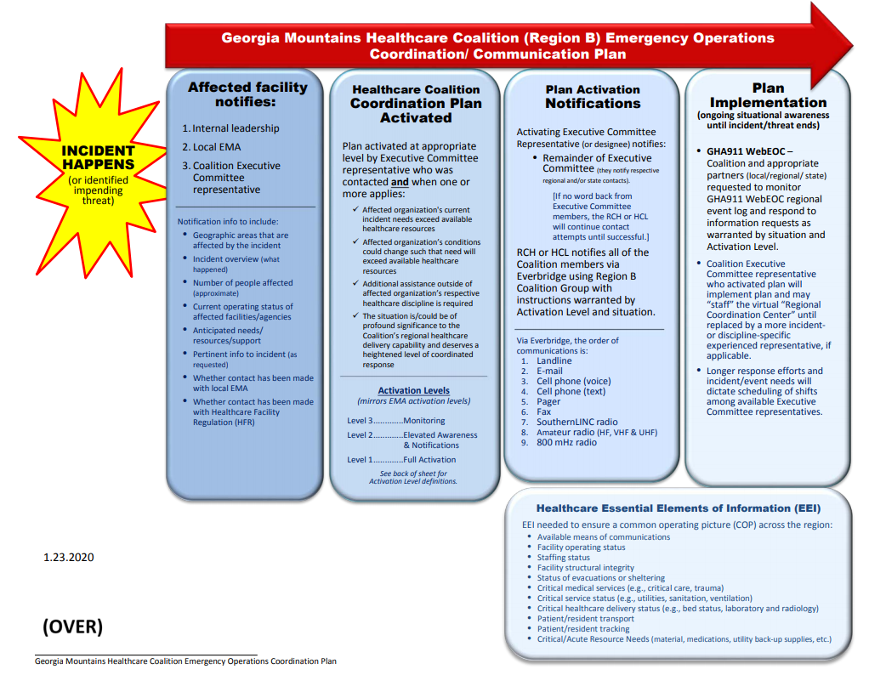
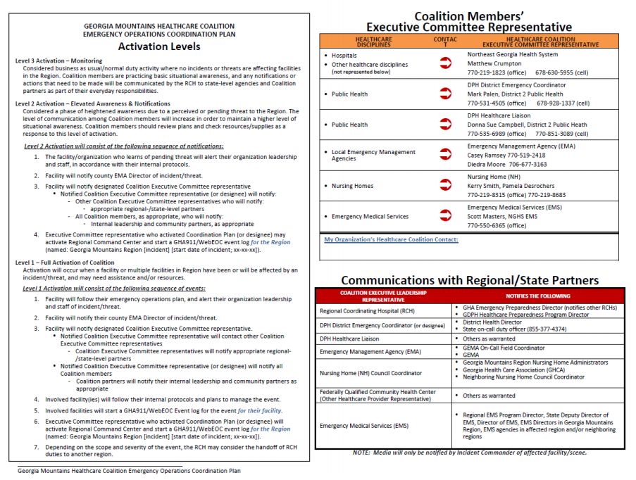

Appendix C: Georgia Mountains Healthcare Coalition (Region B)

Executive Committee Contacts

RCH - Matthew Crumpton
Emergency Preparedness Manager
Coalition Coordinator
Northeast Georgia Health System
(o): 770/219-1823
(c): 678/630-5955
matthew.crumpton@nghs.com

EMA - Casey Ramsey
Hall County EMA
Captain of Special Operations
Department Safety Officer
Hall County Fire Services
(o) 770-503-3215
(c) 770-519-2418
cramsey@hallcounty.org

LTC - Kerry Smith
Executive Director of Long Term Care
New Horizons Lanier Park
(o) 770-219-8315
(c) 678-773-5229
kerry.smith@nghs.com
Coalition Clinical Advisor- Frances Franks
Critical Care Resource Nurse
Northeast Georgia Health System
(c) 334-444-2651
frances.franks@nghs.com

DPH HCL - Donna Sue Campbell
Emergency Preparedness Healthcare Liaison
Coalition Facilitator
District 2 Public Health
(o) 770-535-6989
(c) 770-851-3089
DonnaSue.Campbell@dph.ga.gov
DPH EC – Mark Palen
District 2 Public Health
(o) 770-531-4505
(c) 678-928-1337
Mark.Palen@dph.ga.gov

EMA – Diedra Moore
Banks County EMA / E-911
(o) 706-677-3163
(c) 706-658-5120
dmoore@co.banks.ga.us
LTC-Pamela Desrochers
Manager of Long Term Care
New Horizons Limestone
(o) 770-219-8683
(c) 706-769-0670
Pamela.Desrochers@nghs.com
Hospital - Cecil Solaguren
Environment of Care Director
Union General Hospital
(706) 994-3619
cecilsolaguren@uniongeneral.org

Appendix D: Role of Children’s Healthcare of Atlanta (CHOA)
Children’s Healthcare of Atlanta (CHOA) has contracted with the Georgia Hospital Association (GHA) to act as the Specialty Coordinating Hospital (SCH) for pediatrics with the state of Georgia. In the event of a disaster, CHOA will assist facilities and regions with pediatric patient needs. CHOA Transfer Center can facilitate the acceptance of pediatric patients.
If the scope of the event exceeds the resources of CHOA, we will work with those facilities within Georgia that have pediatric inpatient capabilities for patient placement. CHOA’s is also a signatory to the Southeastern Regional Pediatric Disaster Network and is in contact with numerous pediatric hospitals across the Southeast (Tennessee, North Carolina, South Carolina, Florida, Kentucky, Alabama, and Mississippi). This organization has a memorandum of understanding to support each other in the event of a disaster involving pediatrics.
For assistance with pediatric patient placement, please call the
Children’s Healthcare of Atlanta Transfer Center
404-785-7778 or 1-888-785-7778
Additional responsibilities of the Specialty Coordinating Hospital (SCH)
Children’s Healthcare of Atlanta will:
- Provide technical assistance for hospitals in the development of plans and exercises as well as during real world emergencies upon request.
- Assistance may include providing additional staffing, sharing expertise and distribution of specialty care supplies and equipment through mutual aid during a disaster or evacuation.
- Participate in regional drills to offer pediatric expertise and to encourage pediatric patients to be included in drill casualties to better prepare for world events
For more information on Children’s role as the SCH for pediatrics, please contact Kristopher Mattson at 404-785-7191.
Children’s Healthcare of Atlanta Overview
- CHOA is comprised of three (3) separate hospitals: Egleston, Scottish Rite and Hughes Spalding.
  - Egleston is the only designated Level 1 Pediatric Trauma Center in the state.
  - Scottish Rite is the only designated Level 2 Pediatric Trauma Center in the state.
  - Hughes Spaulding has Pediatric Emergency Department and pediatric general care capabilities.
- Between the 3 campuses, CHOA has over 500 licensed pediatric beds!
- Currently this includes 58 pediatric intensive care beds combined in 2 PICU’s, Neonatal Intensive Care Units (NICU) a Cardiac Intensive Care Unit (CICU) and Technology Dependent Unit (TDICU). Egleston has ECMO capabilities as well.
- CHOA has all pediatric sub-specialties and will accept pediatric patients in transfer when beds are available.
CHOA can assist with the transport of patients. CHOA can provide ground transportation with up to 7 ambulances and 1 helicopter. CHOA can also assist with fixed wing transport.


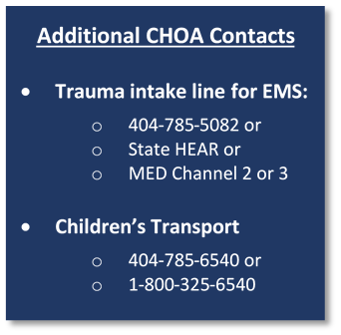

Appendix E: New WebEOC Guide
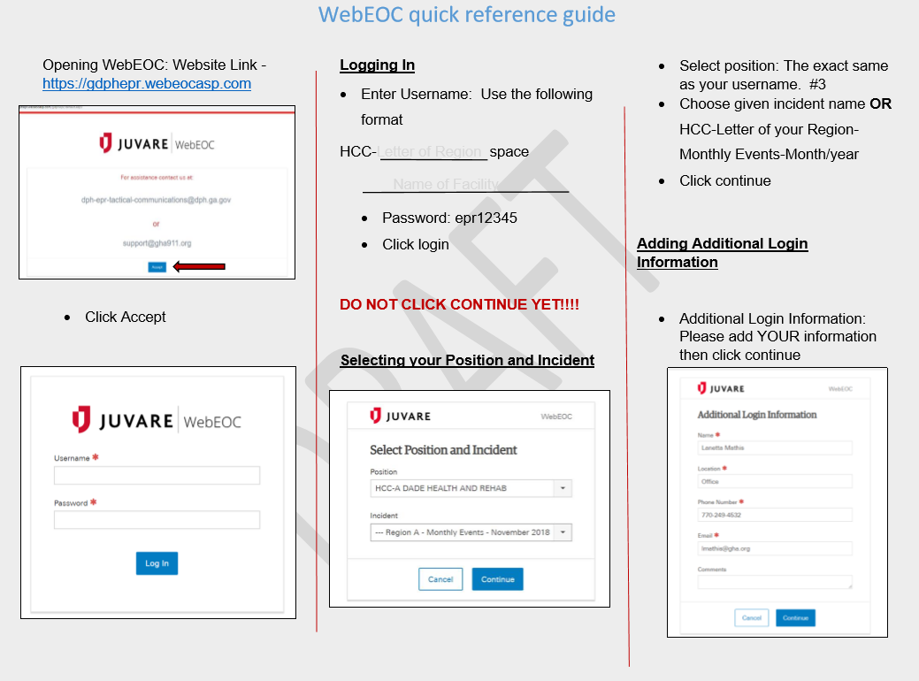
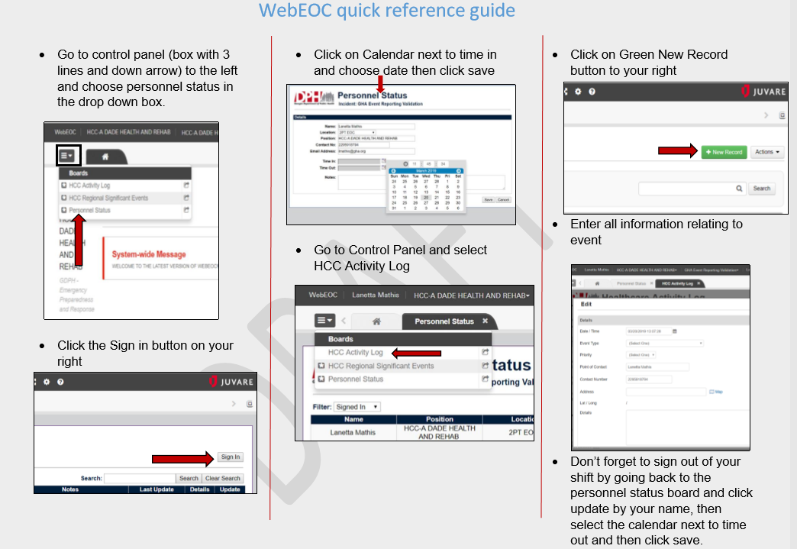

Appendix F: Region B Coalition Members WebEOC Login Information (password = epr12345)
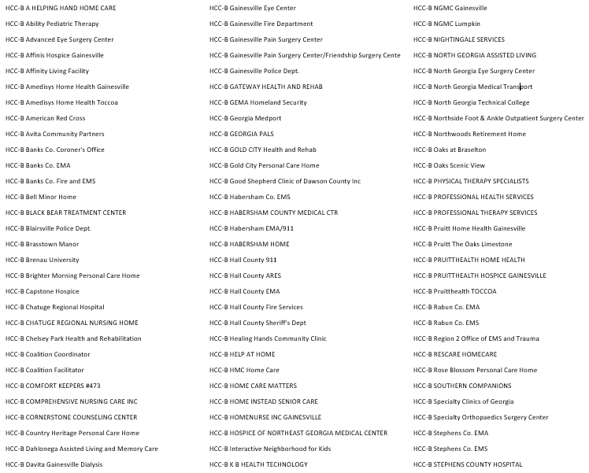
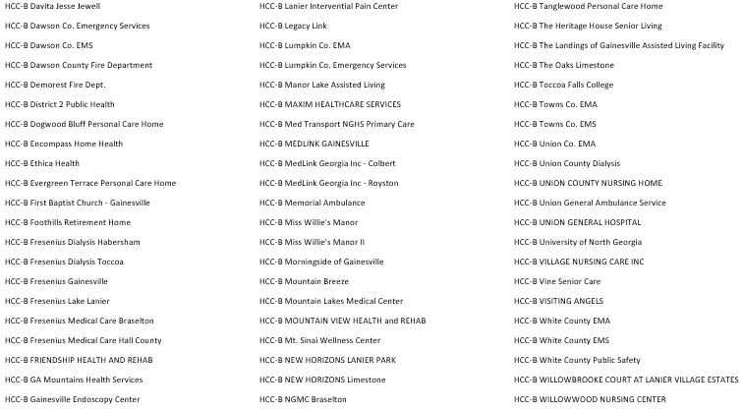

Appendix G: Region B Healthcare Facility Bed Counts
REGION B | FACILITY TYPE | # LICENSED BEDS | CURRENT CENSUS
BANKS
 | TOTAL
DAWSON
 | TOTAL
HABERSHAM
Habersham County Medical Center | Hospital | 137
Habersham Home | Nursing Home | 84
The Oaks Scenic View Skilled Nursing | Nursing Home | 148
 | TOTAL
HALL
Willowbrooke Court At Lanier Village Estates | Nursing Home | 64
New Horizons Limestone | Nursing Home | 134
The Oaks- Limestone | Nursing Home | 104
Willowwood Nursing Center | Nursing Home | 100
The Bell Minor Home | Nursing Home | 104
Northeast Georgia Medical Center | Hospital | 557
NGHS Braselton | Hospital | 100
New Horizons Lanier Park | Nursing Home | 118
 | TOTAL
LUMPKIN
Northeast Georgia Medical Center - Lumpkin | Hospital | 49
Chelsey Park Health and Rehabilitation | Nursing Home | 60
Gold City Health and Rehab | Nursing Home | 102
 | TOTAL
RABUN
Mountain Lakes Medical Center | Hospital | 25
Mountain View Health Care | Nursing Home | 113
 | TOTAL
STEPHENS
Stephens County Hospital | Hospital | 96
Pruitt Health - Toccoa | Nursing Home | 181
 | TOTAL
TOWNS
Chatuge Regional Hospital | Hospital | 137
Chatuge Regional Nursing Home | Nursing Home | 112
 | TOTAL
UNION
Union General Hospital | Hospital | 45
Union County Nursing Home | Nursing Home | 150
 | TOTAL
WHITE
Friendship Health and Rehab | Nursing Home | 89
Gateway Health and Rehab | Nursing Home | 60
 | TOTAL

Appendix H: GHA911 WebEOC Event Log - TTX
Comment | Entered By
Bed counts have been updated. On standby for potential patient intake.  Terry Head as HCC-B Chelsey Park Health and Rehabilitation at 11:24:31 on 11:24:31 | HCC-B Chelsey Park Health and Rehabilitation
On standby for support for potential intake of patients.  Kevin Chamlee as HCC-B Ethica Health at 11:17:16 on 11:17:16 | HCC-B Ethica Health
Bed count updated. Everbridge acknowledged.  Wendell Farmer as HCC-B Chatuge Regional Hospital at 11:14:04 on 11:14:04  Participation in Region B Peds Surge  Wendell Farmer as HCC-B Chatuge Regional Hospital at 11:08:21 on 11:08:21 | HCC-B Chatuge Regional Hospital
We are in a support mode, able to assume care of patients that can be discharged to home to open up beds at the hospital.  Rita Southworth as HCC-B Pruitt Home Health Gainesville at 11:09:59 on 11:09:59 | HCC-B Pruitt Home Health Gainesville
Notification sent to Region B HCC members via Everbridge to test communications and request bedcount updates  Donna Sue Campbell as HCC-B Coalition Facilitator at 10:52:15 on 10:52:15 | HCC-B Coalition Facilitator
EXERCISE EXERCISE EXERCISE  Matthew Crumpton as HCC-B Coalition Coordinator at 10:20:09 on 10:20:09  Local EMS notifies Med Transport of reports of a school explosion during a rural school assembly. Initial reports indicate as many as 50 children and adults in the area at the time of explosion. Estimated number of causalities is unknown, but initial 911 calls report that the situation is dire.  Matthew Crumpton as HCC-B Coalition Coordinator at 10:13:23 on 10:13:23 | HCC-B Coalition Coordinator
Bed counts have been updated. On standby for potential patient intake.  Terry Head as HCC-B Chelsey Park Health and Rehabilitation at 11:24:31 on 11:24:31 | HCC-B Chelsey Park Health and Rehabilitation

Appendix I: Georgia Mountain Healthcare Coalition EverBridge Messages

Georgia Mountains (Region B) Healthcare Coalition
Everbridge Communications Drill After Action Report (AAR)
Jan 29, 2020

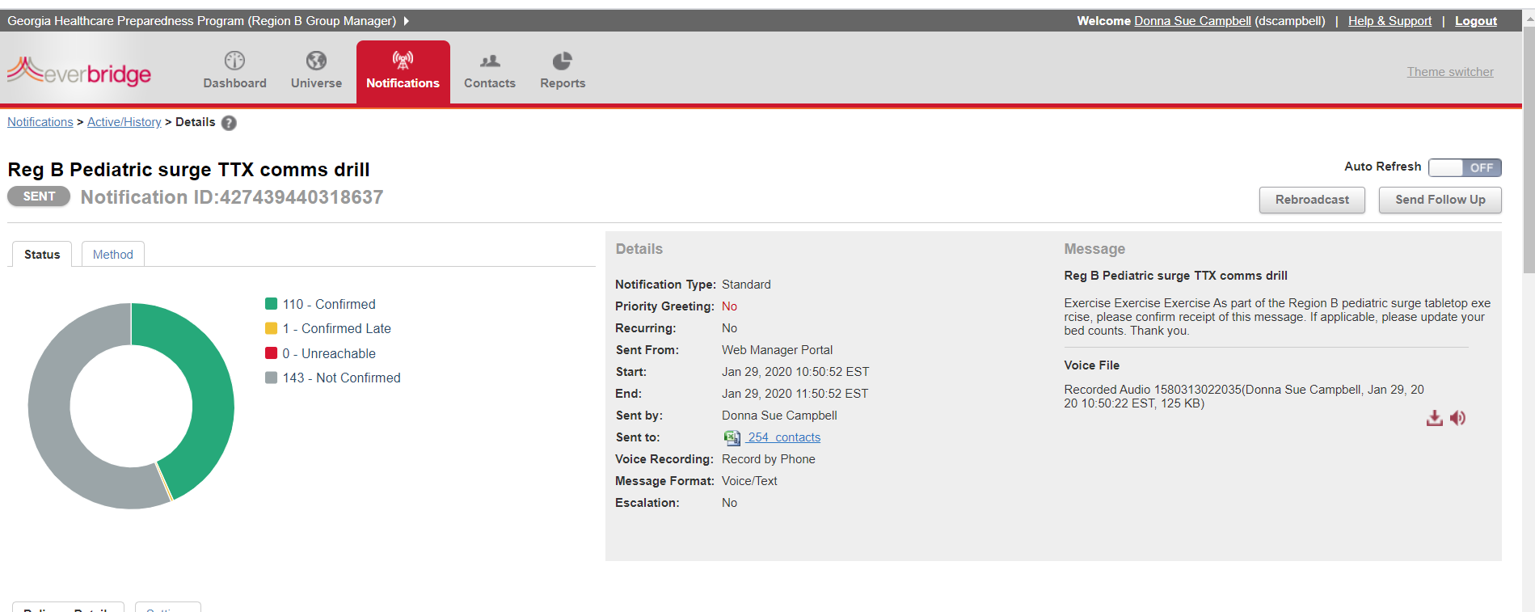

Above message sent to 254 contacts as part of Pediatric Surge Table Top Exercise Jan 29, 2020
- 110 confirmed receipt of message
- 143 did not confirm receipt of message
- All contacts on list were reached by some method, all contacts up to date
- 43% communication response rate
- 71% bed count update response rate

Appendix J: Acronyms
Acronym | Meaning
AAR | After Action Report
ARES | Amateur Radio Emergency Service
CHOA | Children's Healthcare of Atlanta
EEI | Essential Elements of Information
EMA | Emergency Management Agency
EMS | Emergency Medical Services
EOC | Emergency Operations Center
EOP | Emergency Operations Plan
EPD | Environmental Protection Division
EPT | Exercise Planning Team
ESAR-VHP | Emergency System for Advance Registration of Volunteer Health Professionals
ESF | Emergency Support Function
FSE | Full Scale Exercise
GAPHC | Georgia Association for Primary Health Care
GDBHDD | Georgia Department of Behavioral Health and Developmental Disabilities
GDPH | Georgia Department of Public Health
GEMA | Georgia Emergency Management Agency
GHA | Georgia Hospital Association
GHCA | Georgia Health Care Association
HCC | Healthcare Coalition Coordinator
HCF | Healthcare Coalition Facilitator
HICS | Hospital Incident Command System
HSEEP | Homeland Security Exercise Evaluation Program
HVA | Hazard Vulnerability Assessment
HVAC | Heating, Ventilation, and Air Conditioning
ICS | Incident Command System
ISC | Internal Surge Capacity
IT | Information Technology
JIC | Joint Information Center
LE | Law Enforcement
LEPC | Local Emergency Planning Committee
MOU | Memorandum of Understanding
MSEL | Master Scenario Event List
NIMS | National Incident Management System
PAPR | Powered Air Purifying Respirator
PIO | Public Information Officer
PPE | Personal Protective Equipment
RCH | Regional Coordinating Hospital
SERVGA | State Emergency Registry of Volunteers of Georgia
SitMan | Situation Manual
SME | Subject Matter Expert
TTX | Tabletop Exercise

Appendix K: Regional Coordinating Hospital Area Map
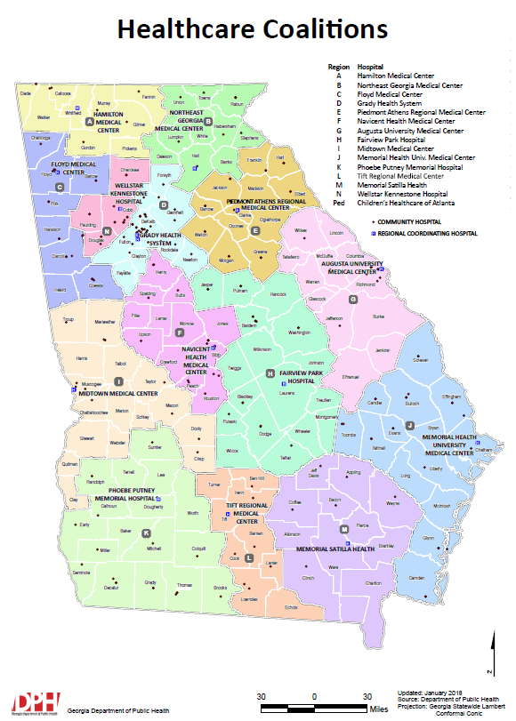

Appendix L: Public Health Districts Map
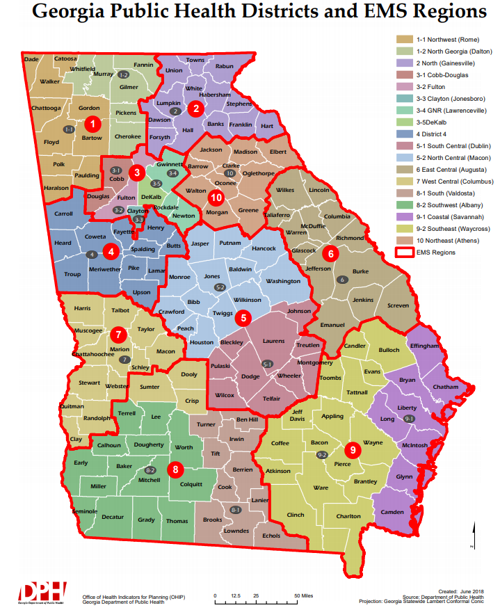

Appendix M: GEMA Regions Map
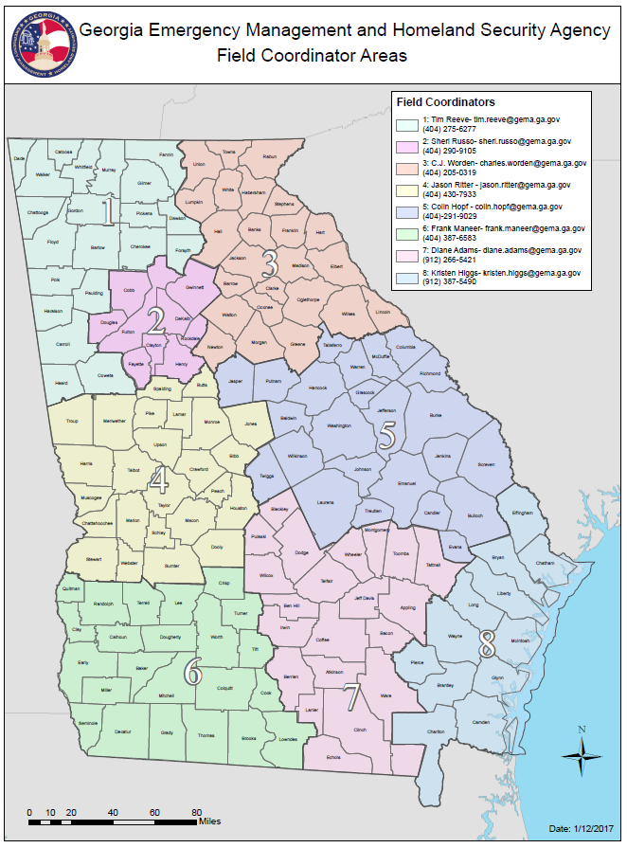

Appendix N:
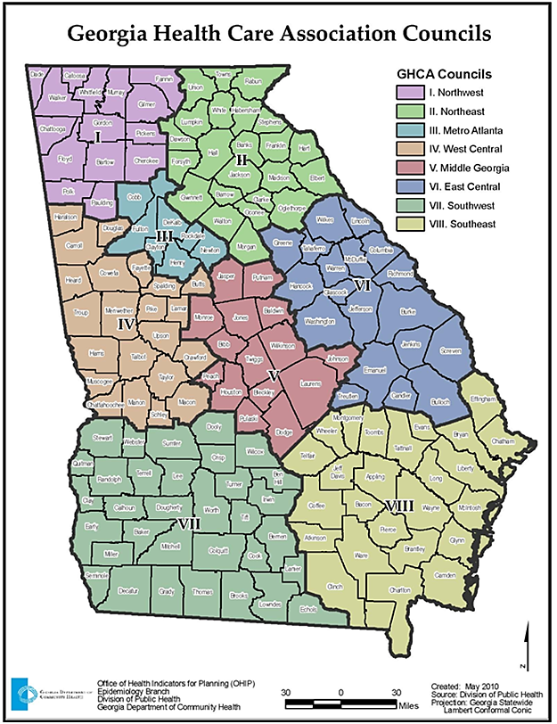

Appendix O: Georgia ARES Districts Map

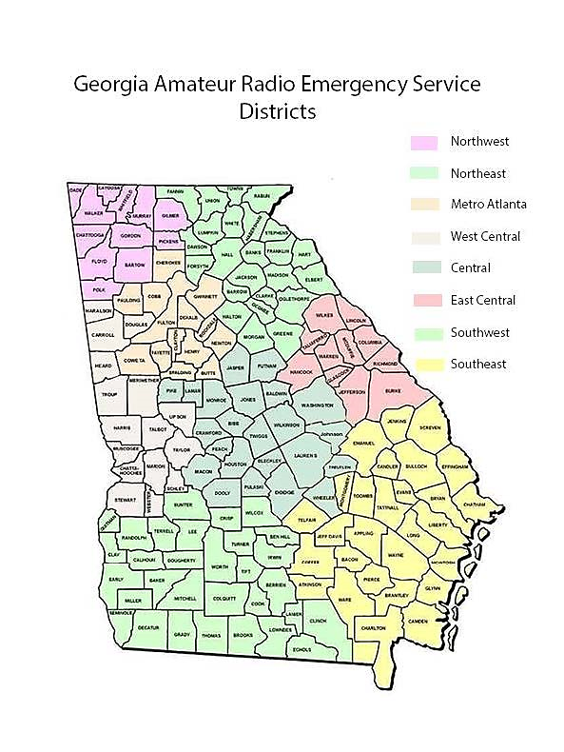

Appendix P: BH Regions Map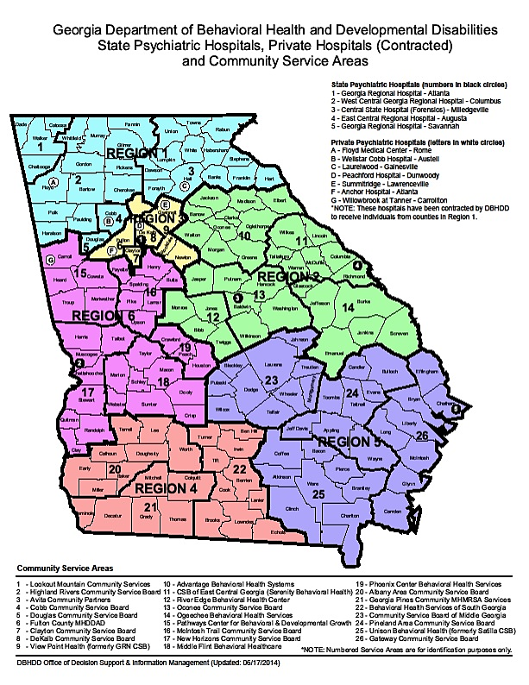

Appendix Q: GEMA Regions Map
